ECA5613 – 5G/6G Communication Systems
ASSIGNMENT REPORT
Design and Development of a 5G/6G-Enabled IoT Network for AI-Driven Crop Yield Prediction in Smart Agriculture

Particulars | Details
Student Name | K. Venugopal Reddy
Register Number | 192312480
Course Code | ECA5613
Course | 5G/6G Communication Systems
Assignment Level | L6 – Create
Primary COs | CO4 and CO5
SDG Mapping | SDG 9 and SDG 15

1. Introduction
Smart agriculture requires communication infrastructure that can connect large numbers of low-power field devices while also supporting aerial imaging, livestock tracking, local analytics and remote cloud services. The supplied assignment asks for a 5G/6G-enabled IoT network covering at least three geographically distributed farm clusters and at least 500 connected low-power IoT sensors. The architecture must combine mMTC-oriented NB-IoT/LTE-M connectivity, spectrum or dynamic-spectrum sharing, Multi-access Edge Computing (MEC), AI/ML, LEO satellite/NTN backhaul and lightweight IoT security.
The proposed design treats each farm cluster as a local sensing and control domain. Soil moisture, temperature, humidity and weather information are collected by constrained devices. UAVs provide aerial crop imagery, while livestock devices provide tracking information. The sensor traffic is carried through a dedicated mMTC-oriented slice. A local MEC server aggregates data and performs low-latency AI inference for crop-yield prediction and irrigation optimization. Where terrestrial coverage is weak, an LEO NTN link provides backhaul toward the cloud.

1.1 Assignment Requirements
Requirement | Proposed design response
Farm coverage | 3 geographically distributed farm clusters
IoT scale | At least 500 low-power sensors; design target: 510
Sensing | Soil moisture, temperature, humidity and weather stations
Additional devices | UAV/drone fleet and livestock tracking devices
Low-power access | NB-IoT/LTE-M within an mMTC-oriented network slice
Edge computing | MEC node at/on each cluster or shared regional edge
Backhaul | LEO satellite / NTN for remote coverage
AI | Edge-AI crop-yield prediction and irrigation optimization
Security | Authentication, encryption, anomaly/spoofing detection
Validation | Network simulation/emulation plus controlled attack tests
Metrics | Latency, PDR, throughput, availability/coverage, energy/device, detection time

2. Objectives and Requirements Analysis

2.1 Objectives
- Connect 500+ constrained agricultural sensors across three farm clusters.
- Use NB-IoT/LTE-M to support large-scale, low-power, wide-area sensing.
- Isolate sensor traffic using an mMTC-oriented network slice.
- Use MEC to reduce the delay of AI inference and irrigation decisions.
- Use LEO NTN backhaul where terrestrial connectivity is unavailable or unreliable.
- Protect devices and data using lightweight authentication and encryption.
- Detect anomalous or spoofed sensor readings before they influence AI decisions.
- Validate the architecture against four controlled attack scenarios.
- Evaluate at least six measurable network and security parameters.
- Assess scalability, energy efficiency, resilience and prediction-pipeline reliability.

2.2 Sensor and Device Population
Device category | Cluster 1 | Cluster 2 | Cluster 3 | Total
Soil-moisture sensors | 80 | 80 | 80 | 240
Temperature sensors | 35 | 35 | 35 | 105
Humidity sensors | 25 | 25 | 25 | 75
Weather-station sensors | 20 | 20 | 20 | 60
Other low-power field nodes | 10 | 10 | 10 | 30
Total low-power sensors | 170 | 170 | 170 | 510
UAV / drone units | 2 | 2 | 2 | 6
Livestock tracking units | 10 | 15 | 10 | 35

3. Proposed 5G/6G IoT Network Architecture
The logical architecture is organized into five layers: field sensing, radio access and mMTC slicing, edge/MEC processing, NTN/cloud transport, and application/AI services. The three farm clusters share the same overall design while operating as independent local domains.
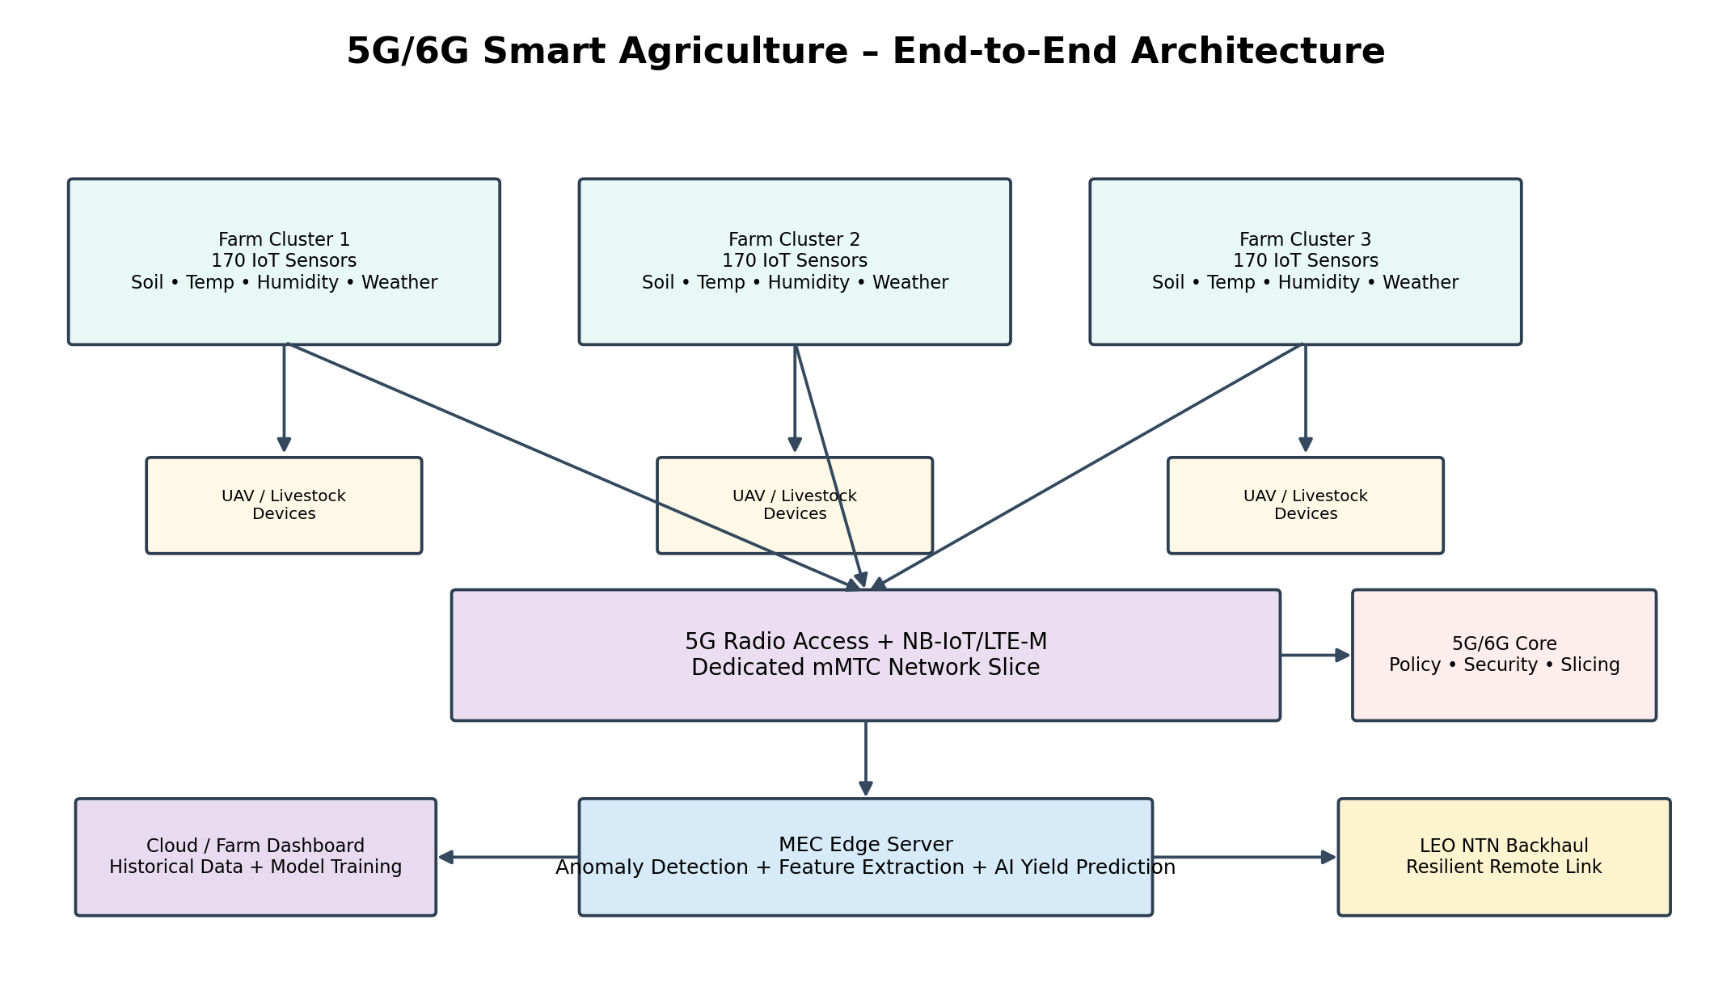
Figure 1. Proposed 5G/6G IoT architecture for three distributed farm clusters.
Figure 1. Proposed logical architecture for the three-cluster smart-agriculture network.

3.1 Field Sensing Layer
The field layer contains soil-moisture, temperature, humidity and weather-station sensors. These devices are constrained in processing power and battery capacity, so their traffic is periodic and relatively small. UAVs generate larger bursts of aerial imagery and livestock trackers generate location/status messages. These traffic classes are therefore logically distinguished even when they share the broader agricultural network.

3.2 Radio and mMTC Slice
The mMTC slice is optimized for high device density and low signaling/data rates. NB-IoT is suitable for deeply constrained periodic telemetry, while LTE-M can support devices that need somewhat higher throughput or mobility, including selected trackers. The slice is isolated from higher-bandwidth aerial-imaging traffic so that large UAV uploads do not consume the resources needed by routine sensing.
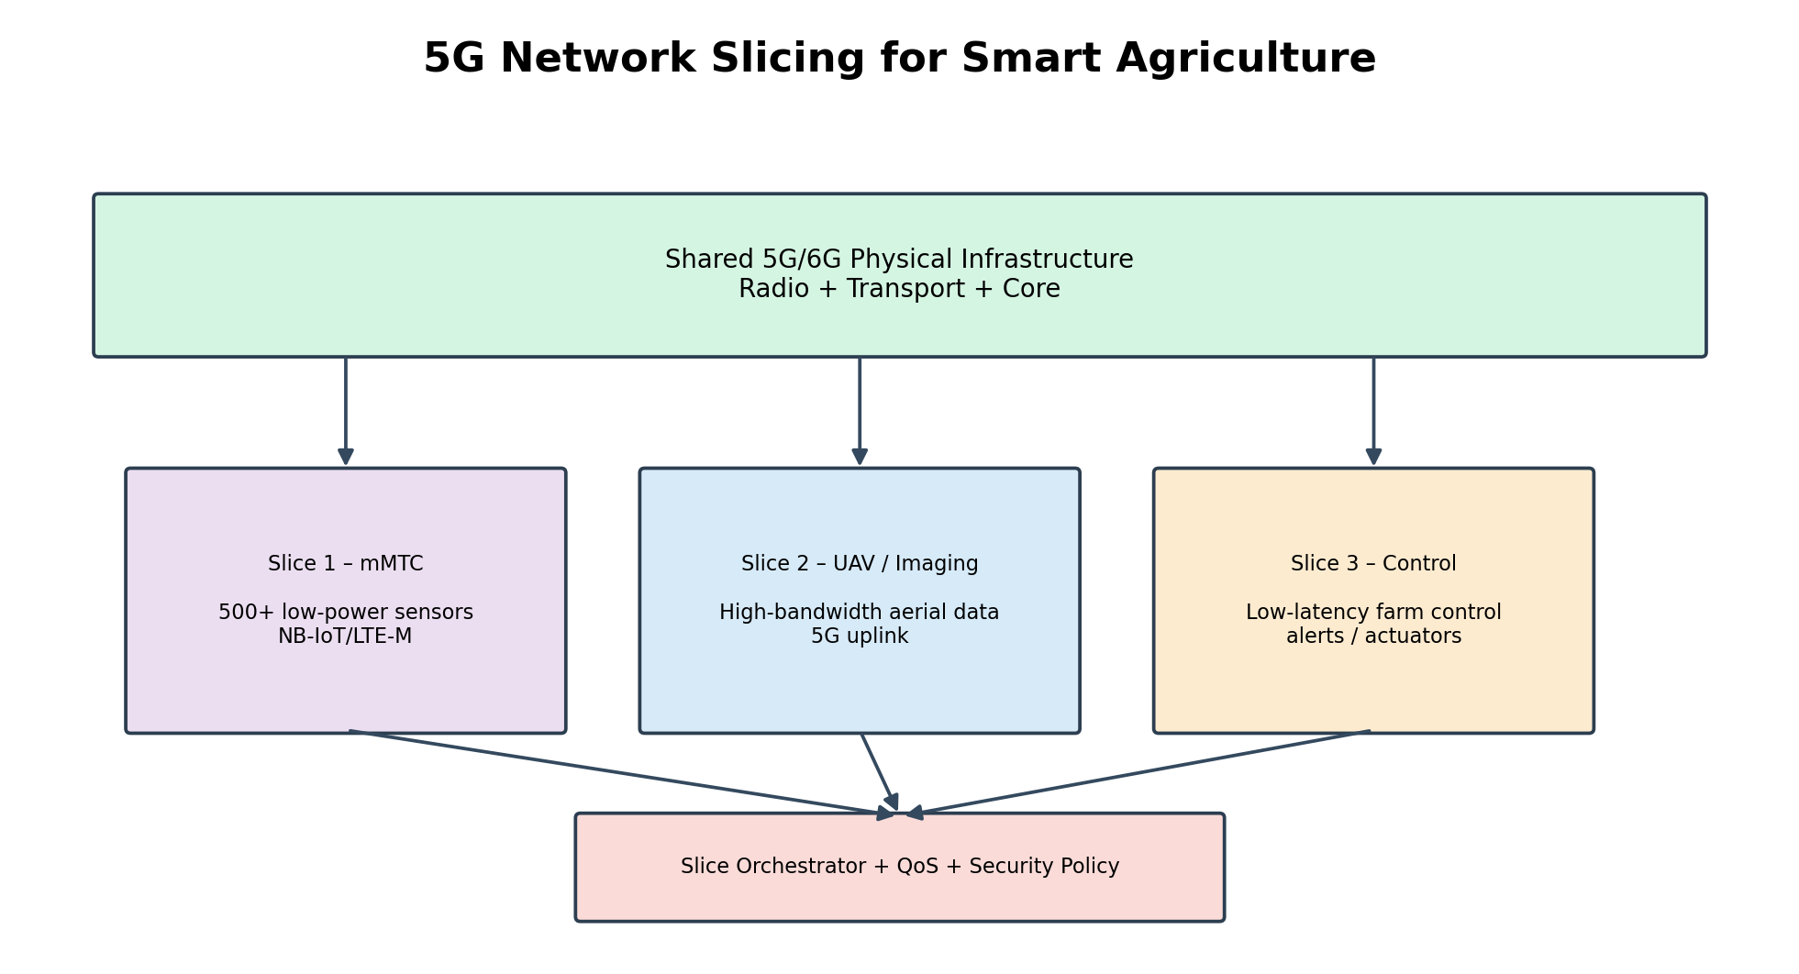
Figure 2. Logical 5G/6G network slicing strategy for agricultural services.

3.3 MEC Layer
The MEC server receives cleaned sensor streams, performs feature construction and runs the edge-AI inference loop. Local inference is preferred for irrigation decisions because it avoids unnecessary backhaul delay. Only selected summaries, model updates and historical data need to traverse the NTN link to the cloud.
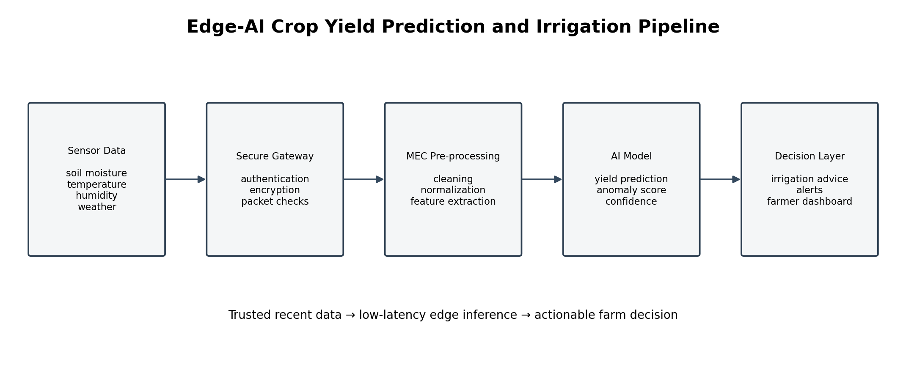
Figure 3. Edge-AI pipeline from sensor telemetry to yield prediction and irrigation decisions.

4. 5G/6G Core, Connectivity and Network Slicing

4.1 5G Service-Based Architecture Concept
The proposed network separates access, policy, session and application functions conceptually. The IoT slice receives dedicated logical resources and policy rules. Device traffic is authenticated before it is admitted to the slice, and the edge application consumes the authorized data stream.

4.2 mMTC Slice Definition
Slice attribute | Design choice | Reason
Service type | mMTC / agricultural telemetry | Large device population with low-rate traffic
Primary access | NB-IoT | Deep coverage and low device energy demand
Secondary access | LTE-M | Mobility and moderate-rate device support
Isolation | Logical slice with dedicated policies | Protect sensor traffic from competing applications
Edge placement | MEC close to farm clusters | Reduce inference and control latency
Backhaul | Terrestrial where available; LEO NTN otherwise | Improve remote-farm resilience
QoS focus | Reliability and energy efficiency | Periodic measurements are more important than peak rate

4.3 Spectrum and Dynamic-Spectrum-Sharing Strategy
The proposed approach is policy-controlled sharing: reserve a predictable resource portion for mMTC telemetry, allocate additional capacity when UAV traffic increases, and avoid persistent occupation of resources that are not required. In simulation, this can be represented by separate logical resource pools and adaptive allocation according to measured load.

4.4 Data Flow
Sensor → NB-IoT/LTE-M access → mMTC slice → MEC aggregation → anomaly screening → feature extraction → edge-AI inference → irrigation recommendation. A copy or summary is then sent through terrestrial or LEO NTN backhaul to cloud analytics for dashboards, storage and longer-term model management.

5. MEC and Edge-AI Yield Prediction Pipeline

5.1 Edge Processing Pipeline
Stage | Operation | Output
1. Ingestion | Receive sensor/UAV/tracker messages | Raw edge stream
2. Validation | Check identity, timestamp, range and message integrity | Validated records
3. Anomaly detection | Compare measurements with expected spatial/temporal behavior | Normal/anomalous flag
4. Preprocessing | Handle missing values and normalize features | Clean feature set
5. Feature engineering | Build rolling environmental/crop-condition features | Model input vector
6. Inference | Run trained yield-prediction model at MEC | Predicted yield
7. Optimization | Use prediction + moisture state to recommend irrigation | Irrigation action/recommendation
8. Cloud sync | Send summaries/model statistics/historical data | Long-term analytics

5.2 Yield Prediction
A regression-based machine-learning model can be trained using historical agricultural observations. Candidate inputs include soil moisture, temperature, humidity, weather-station values and time-related crop-stage features. The edge deployment should favor a compact model so that inference is fast and computationally economical.
ŷ = f(soil moisture, temperature, humidity, weather features, crop-stage features)
where ŷ is the predicted crop yield and f is the trained regression model. The implementation should record the timestamp of the newest input, inference start/end times and prediction output.

5.3 Irrigation Optimization
Irrigation is triggered or recommended only when sensor validity is high and the soil-moisture state indicates a need. A simple decision layer can combine predicted yield impact with moisture thresholds. Human oversight should remain part of operational decisions.

6. LEO NTN Backhaul and Resilience
LEO NTN is primarily used as a backhaul mechanism rather than the main local sensor-access technology. This allows the field network to retain efficient NB-IoT/LTE-M operation while using the satellite path when terrestrial backhaul is weak or unavailable.
Mode | Condition | Traffic carried
Normal terrestrial | Reliable terrestrial coverage | Routine telemetry, summaries and cloud synchronization
NTN backup | Terrestrial path degraded | Essential telemetry, alarms and edge summaries
NTN remote mode | No practical terrestrial backhaul | Essential sensor data and selected application traffic
Recovery | Terrestrial service restored | Buffered data synchronization

6.1 Resilience Mechanism
The MEC node buffers measurements when the backhaul is temporarily unavailable. Priority is given to recent measurements, alarms and security events. Historical bulk data can be transferred later.

6.2 Design Trade-off
LEO NTN improves coverage and resilience but introduces additional link-management complexity and potentially higher energy/communication cost. The design therefore minimizes satellite traffic by performing aggregation and AI inference at the edge.

7. IoT Security Architecture
The security design follows a layered approach: device identity, authenticated admission, encrypted transport, message integrity, edge validation and centralized event logging.
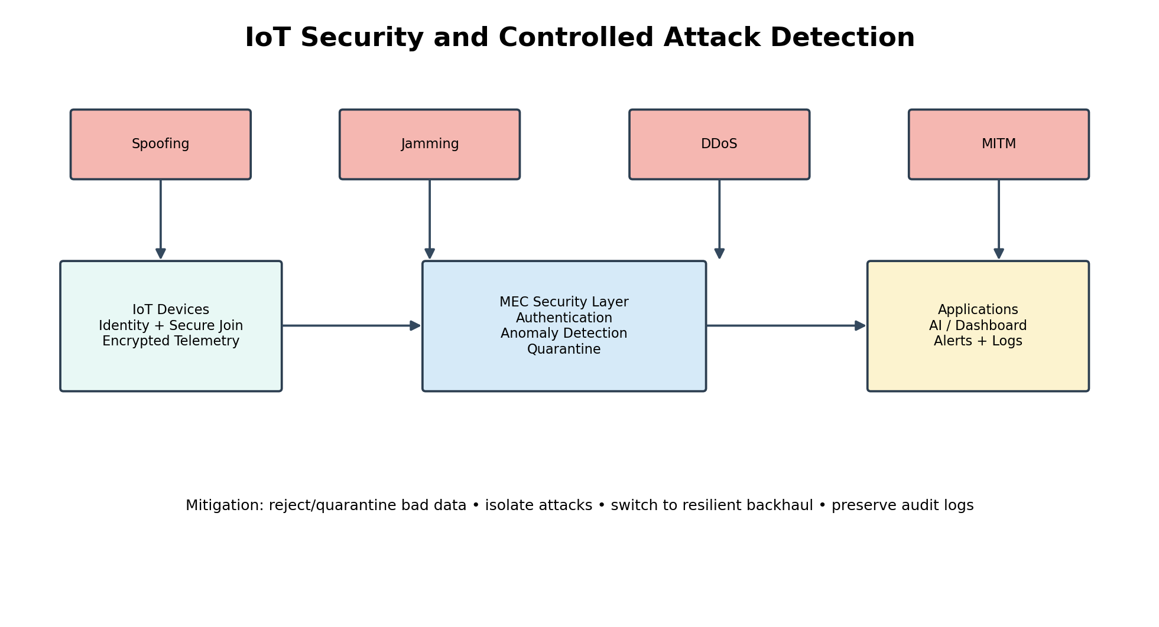
Figure 4. Security architecture and controlled attack scenarios.
Security layer | Control | Purpose
Identity | Unique device identifier and provisioned credential | Prevent unknown devices from joining
Authentication | Lightweight device authentication | Verify device legitimacy
Confidentiality | Lightweight symmetric encryption | Protect sensor data
Integrity | Message integrity/authentication tag | Detect modification
Access control | Slice and application authorization | Limit permitted services
Anomaly detection | Range, temporal and spatial consistency checks | Detect spoofed data
Edge protection | Rate limiting and admission control | Reduce DDoS impact
Audit | Security-event logging | Support incident analysis

7.1 Sensor/Data Spoofing Detection
The MEC layer compares each reading with physical limits, recent history and nearby sensor behavior. Repeated anomalies from one device can reduce its trust score and prevent its values from directly influencing the AI pipeline until the device is revalidated.

7.2 Privacy and Data Responsibility
Farmer and field data should be collected only for the stated agricultural purpose, protected during transmission and retained according to an appropriate policy. Access to dashboards and historical datasets should be role-controlled.

8. Controlled Security / Attack Scenarios
The assignment requires at least four controlled attack scenarios and evidence of methodology, detection, mitigation and observations. The following test plan is designed for a safe simulation/emulation environment.
Scenario | Attack action | Detection | Mitigation | Metric
Sensor spoofing | Inject false soil-moisture readings | Range + temporal/spatial anomaly model | Quarantine/reject suspicious source | Detection time
Jamming | Model increased packet loss/interference | PDR and link-quality threshold | Resource adaptation / alternate path / buffering | PDR, availability
Edge DDoS | Excessive requests toward edge service | Rate and queue monitoring | Rate limiting, admission control | Latency, throughput
MITM upload | Model modified/unauthorized upload | Authentication/integrity check | Reject altered messages; re-authenticate | Detection time, PDR

8.1 Test Procedure
For each scenario, first run a normal baseline, then enable the controlled attack for a fixed simulation interval, record the selected metrics, activate mitigation, and compare the recovered state with baseline. Screenshots/logs should show the attack, detection event and mitigation action.

8.2 Expected Security Behavior
A successful design should reject or quarantine spoofed measurements, limit the impact of jamming, constrain DDoS traffic before edge exhaustion, and reject altered upload messages through integrity/authentication checks. Numerical results must come from the simulator and should not be fabricated.

9. Simulation and Emulation Methodology
The supplied assignment lists NS-3, MATLAB 5G Toolbox/IoT modules, OMNeT++, and Mininet/ONOS as suitable tools. A practical implementation can use NS-3 for network behavior and MATLAB/Python for AI analysis, or an equivalent integrated environment.
Component | Simulation representation
3 farm clusters | Three logical geographic cells/domains
510 sensors | Low-rate periodic application nodes
NB-IoT/LTE-M | Low-power wide-area access abstraction
mMTC slice | Logical resource/QoS class
UAVs | Bursty higher-rate traffic sources
Livestock trackers | Periodic mobile/status traffic
MEC | Low-delay edge application/server node
LEO NTN | Remote-backhaul path abstraction
Cloud | Central analytics/storage endpoint
Attacks | Controlled packet/data manipulation models

9.1 Simulation Steps
- Create the three farm clusters and place sensor nodes.
- Assign device applications and traffic intervals.
- Configure the mMTC logical slice and access parameters.
- Add MEC aggregation and AI-inference application delay.
- Add terrestrial and LEO NTN backhaul paths.
- Run the baseline without attacks.
- Execute each of the four controlled security scenarios separately.
- Record the six or more evaluation metrics.
- Compare baseline, attack and mitigation phases.
- Export logs, graphs and screenshots as submission evidence.

10. Performance Evaluation Framework
The assignment asks for at least six measurable parameters. The following framework uses six primary metrics and adds prediction freshness as an AI reliability indicator.
Metric | Definition | Why it matters
Latency | Time from sensor generation to successful receipt/inference | Responsiveness
Packet Delivery Ratio (PDR) | Received packets / transmitted packets | Communication reliability
Throughput | Successfully delivered data per unit time | Available capacity
Availability/Coverage | Fraction of time the service/path is usable | Rural service continuity
Energy consumption/device | Energy used per sensor | Suitability for constrained nodes
Threat detection time | Time from attack/anomaly onset to detection | Security responsiveness
Prediction freshness | Age of newest data used for inference | AI decision reliability

10.1 Result Table to Populate from Simulation
Condition | Latency | PDR | Throughput | Availability | Energy/device | Detection time
Normal | Measure | Measure | Measure | Measure | Measure | N/A
Spoofing | Measure | Measure | Measure | Measure | Measure | Measure
Jamming | Measure | Measure | Measure | Measure | Measure | Measure
DDoS | Measure | Measure | Measure | Measure | Measure | Measure
MITM | Measure | Measure | Measure | Measure | Measure | Measure
After mitigation | Measure | Measure | Measure | Measure | Measure | Measure

Actual numerical values should be generated by the selected simulation/emulation tool. The supplied assignment specifies the metrics but does not provide experimental measurements.

11. AI, Optimization and Reliability Analysis

11.1 Scalability
The architecture scales by keeping field telemetry lightweight, separating traffic classes and moving computation to the edge. Increasing the sensor population mainly increases periodic low-rate traffic and device-management load.

11.2 Energy Efficiency
Sensor energy is influenced by radio transmission time, reporting interval, retransmissions and processing. NB-IoT is selected for constrained periodic sensors, while aggregation reduces unnecessary transmissions.

11.3 Resilience
Resilience comes from local edge operation, buffering during backhaul disruption and LEO NTN as an alternative remote path.

11.4 Prediction-Pipeline Reliability
AI output should depend on trusted, recent and sufficiently complete input data. The pipeline should record freshness, missing-value rates, anomaly counts and inference latency.

11.5 Engineering Trade-offs
Decision | Benefit | Trade-off
NB-IoT for dense sensing | Low-power wide-area operation | Limited data rate
LTE-M for selected devices | Supports mobility/moderate data | Higher resource/energy demand
mMTC slice | Protects dense telemetry | Requires policy management
MEC AI inference | Low application latency | Edge compute resources required
LEO NTN backup | Remote coverage/resilience | Additional link complexity
Anomaly detection | Improves data integrity | Can create false positives
Local buffering | Continues service during outages | Requires storage/synchronization

12. SDG Alignment, Ethics and Professional Responsibility
The supplied assignment maps the work to SDG 9 – Industry, Innovation and Infrastructure and SDG 15 – Life on Land. The proposed system extends modern communication infrastructure into rural agricultural environments and supports more informed land and resource management.
Area | Contribution
SDG 9 | Scalable 5G/IoT, mMTC connectivity, MEC and NTN backhaul support rural digital infrastructure.
SDG 15 | Sensing and AI-assisted irrigation decisions support informed and potentially resource-efficient land management.
Farmer privacy | Restrict access, protect data in transit and minimize unnecessary collection.
Environmental responsibility | Use energy-aware sensing and local processing; avoid unnecessary transmissions.
Professional responsibility | Validate assumptions, document limitations and do not present unmeasured results as facts.
AI responsibility | Keep human oversight and communicate uncertainty when sensor quality is poor.

13. Implementation Plan and Submission Checklist
Phase | Work | Evidence
1 | Requirements and topology definition | Requirement table + architecture diagram
2 | Farm/sensor population modeling | Node configuration and placement
3 | mMTC slice and connectivity | Slice/access configuration screenshots
4 | MEC and AI pipeline | Edge logs + sample predictions
5 | NTN backhaul model | Backhaul configuration and failover logs
6 | Security controls | Authentication/encryption/anomaly rules
7 | Attack experiments | Four attack logs/screenshots
8 | Performance evaluation | Metric tables and graphs
9 | Engineering analysis | Scalability, energy, resilience and trade-offs
10 | Final documentation | Report + individual reflection

13.1 Submission Checklist
S.No. | Deliverable | Status
1 | Technical Report | Prepared
2 | Network Architecture Diagram | Design provided; final graphical figure can be inserted
3 | Spectrum & mMTC Slicing Design | Prepared
4 | Configuration Files / Screenshots | To be captured from simulator
5 | Simulation / Emulation Project Files | To be submitted with project
6 | Security Testing Evidence | Test plan provided; logs/screenshots to be generated
7 | Performance Evaluation Results | Measurement framework provided; populate after runs
8 | Edge-AI Yield Prediction Evidence | Pipeline and evidence plan provided
9 | Engineering Analysis & Design Justification | Prepared
10 | Individual Reflection | Prepared

14. Individual Reflection
<b>(i) Most challenging aspect:</b> The most challenging aspect was integrating several technologies into one coherent agricultural network. The system requires 5G/6G concepts, mMTC slicing, edge computing, satellite backhaul, AI and security to operate together.
<b>(ii) Most useful 5G/6G/IoT concept:</b> The mMTC concept was especially useful because agricultural deployments can contain hundreds or thousands of low-power devices. Network slicing provides logical protection for dense sensor traffic.
<b>(iii) Most useful security/AI concept:</b> Edge-based anomaly detection was useful because it connects communication security with AI reliability. A corrupted sensor value can affect both network monitoring and crop prediction.
<b>(iv) Technical problem encountered:</b> A major concern is the difference between periodic low-rate sensor traffic and bursty UAV image traffic. Treating both identically could cause congestion and reduce telemetry reliability.
<b>(v) How it was solved:</b> The design separates mMTC sensor service from higher-bandwidth traffic and performs aggregation and AI inference at MEC, reducing data sent across remote backhaul.
<b>(vi) Lessons learned from modern tools:</b> Simulation and emulation tools make it possible to test scale, attacks and performance before deployment. Logs and measured metrics are necessary for engineering conclusions.
<b>(vii) Engineering decision I would change:</b> With additional resources, I would compare multiple edge-AI models and backhaul policies to provide stronger evidence for design trade-offs.
<b>(viii) Improvement in understanding:</b> The assignment improved my understanding of how real-world agricultural IoT networks combine sensing, wireless connectivity, edge intelligence, resilient backhaul and cybersecurity, and how these technologies relate to SDG objectives.

15. Conclusion
This report presents a design framework for the ECA5613 assignment: a 5G/6G-enabled IoT communication network for AI-driven crop-yield prediction and precision farming across three geographically distributed farm clusters. The design exceeds the minimum sensor requirement with 510 low-power sensors and includes UAV and livestock-tracking devices.
NB-IoT/LTE-M connectivity and an mMTC-oriented slice address dense, low-power agricultural telemetry. MEC provides local data aggregation and AI inference, while LEO NTN backhaul improves connectivity resilience for remote farms. Lightweight authentication, encryption, integrity protection and anomaly detection address the security requirements. Four controlled attack scenarios—spoofing, jamming, DDoS and MITM—are incorporated into the validation methodology.
The evaluation framework covers latency, packet delivery ratio, throughput, availability/coverage, energy consumption per device and threat detection time, with prediction freshness as an additional AI reliability metric. Actual numerical results should be generated by the selected simulator and inserted into the report rather than fabricated.
Overall, the proposed architecture emphasizes scalability, energy efficiency, resilience, secure data handling and edge intelligence. It addresses the assignment's CO4/CO5 focus on 5G-enabled IoT, advanced wireless technologies, AI-based optimization and security, while mapping the agricultural application to SDG 9 and SDG 15.
Diagram note: Figures 1–4 are original conceptual block diagrams created for this report to visually represent the proposed architecture, slicing, Edge-AI pipeline and security testing flow.

16. Source Basis
This document is based on the uploaded ECA5613 – 5G/6G Communication Systems assignment specification. The source defines the assignment title, CO mapping, L6/Create level, SDG mapping, the three-cluster/500+ sensor architecture requirements, mMTC/NB-IoT/LTE-M, MEC, LEO NTN, security testing, performance metrics and the ten submission deliverables.

